Task 1 :Create and attach an EBS volume to an EC2 instance

Choose ec2

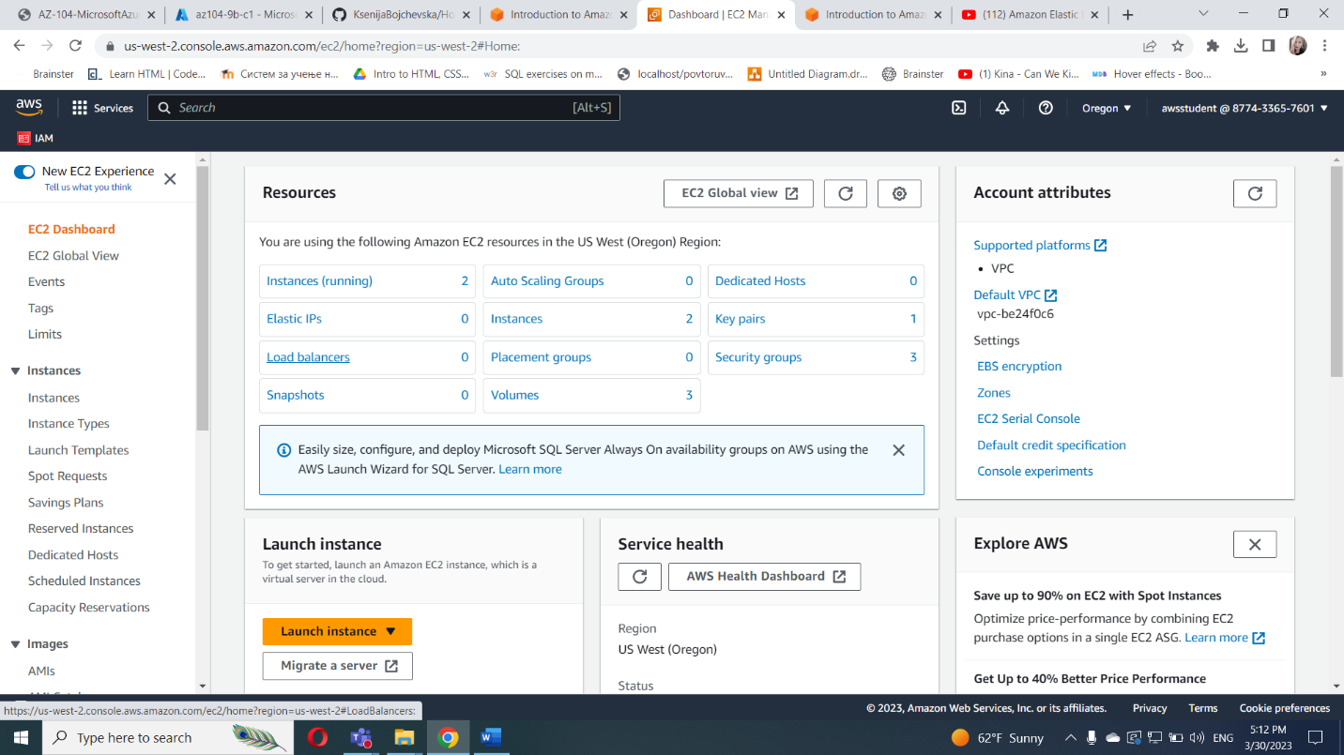

Choose volumes

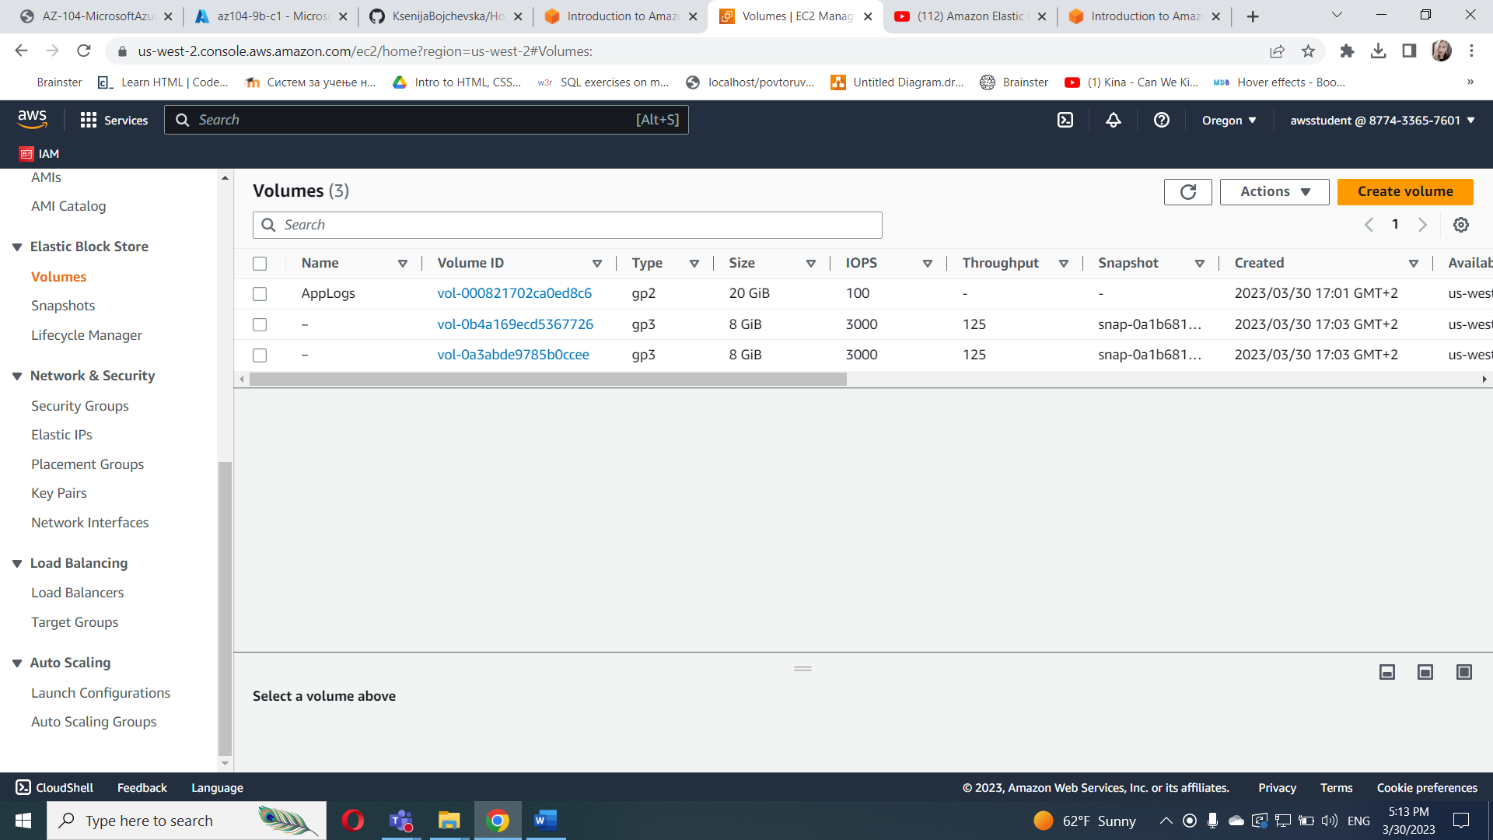

Volume state – in-use

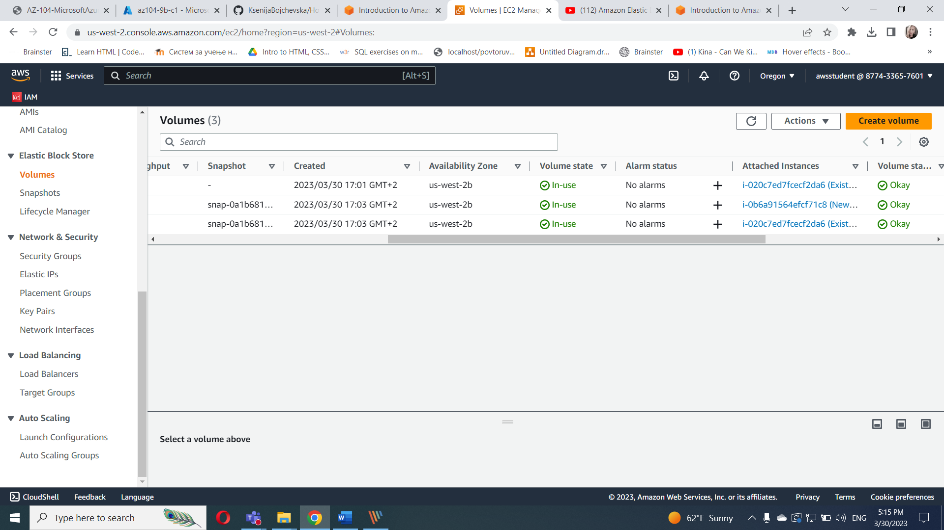

In the name column set Boot_Vol_1 and Boot_Vol_2

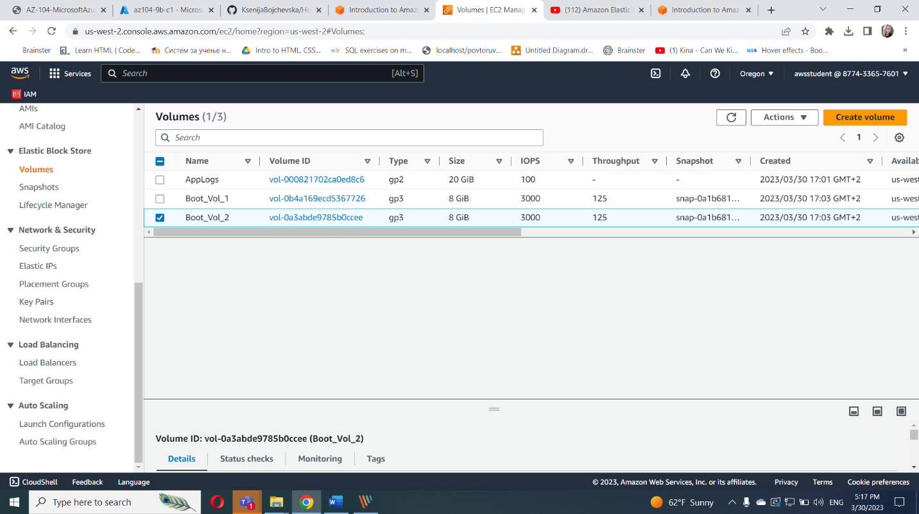

availability zone is

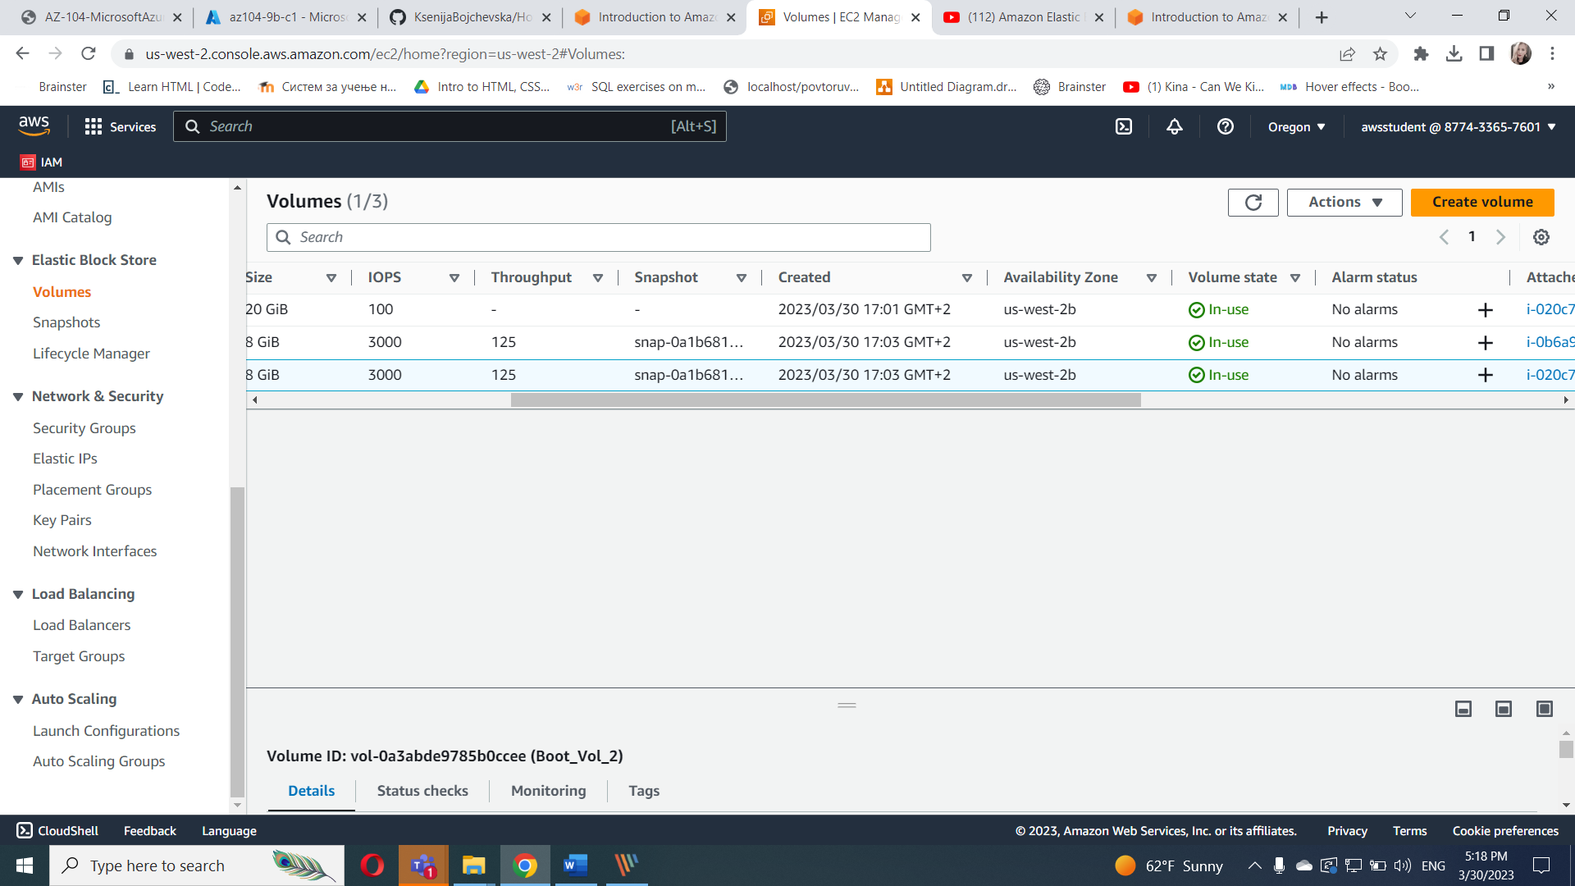

Task 1.2 Create an EBS volume

Create Volume

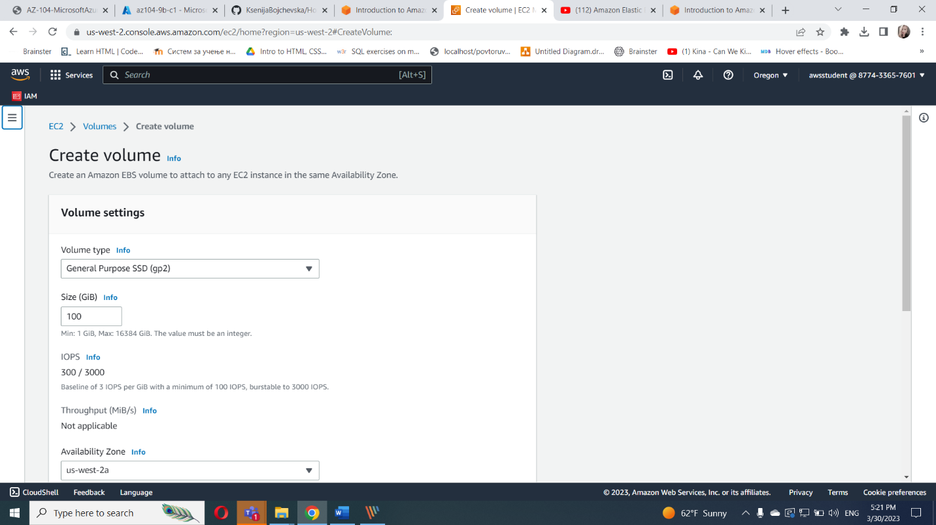

Configuration options for volume

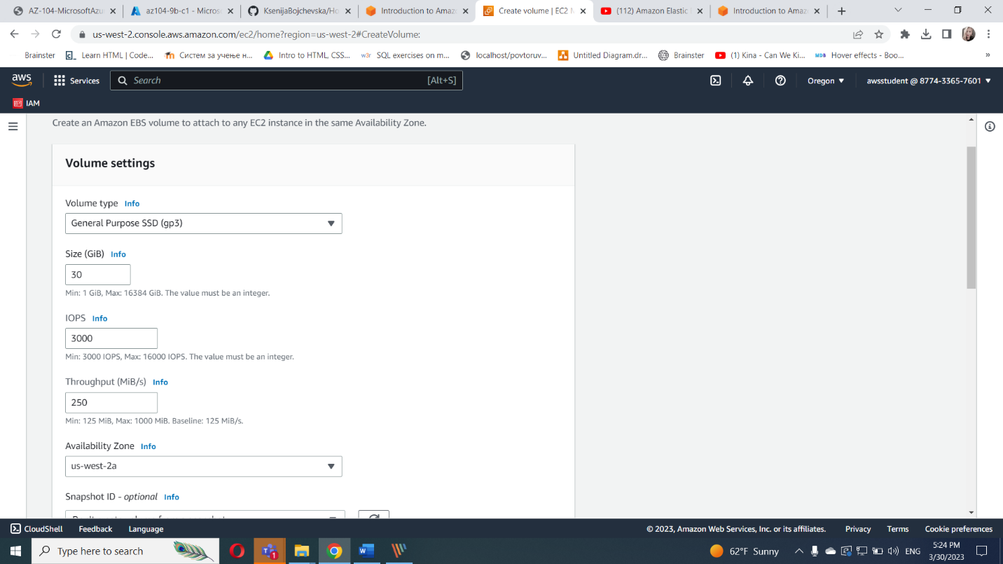

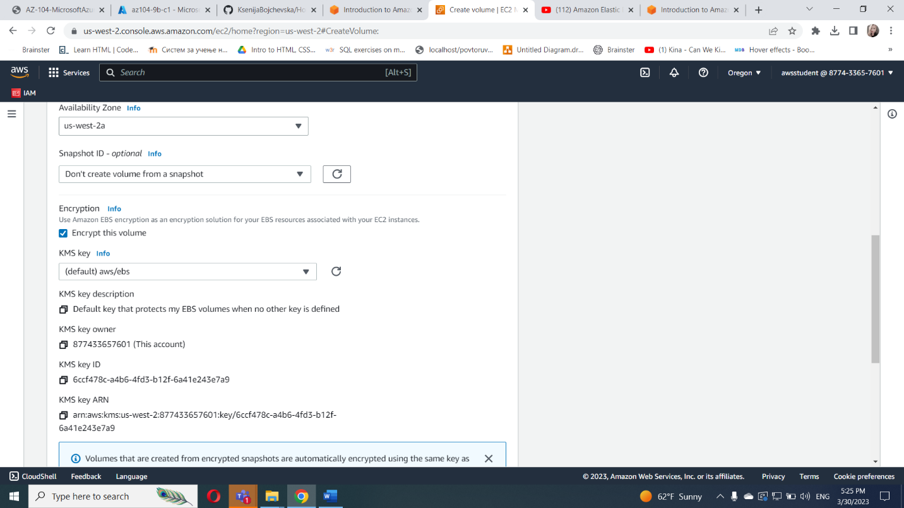

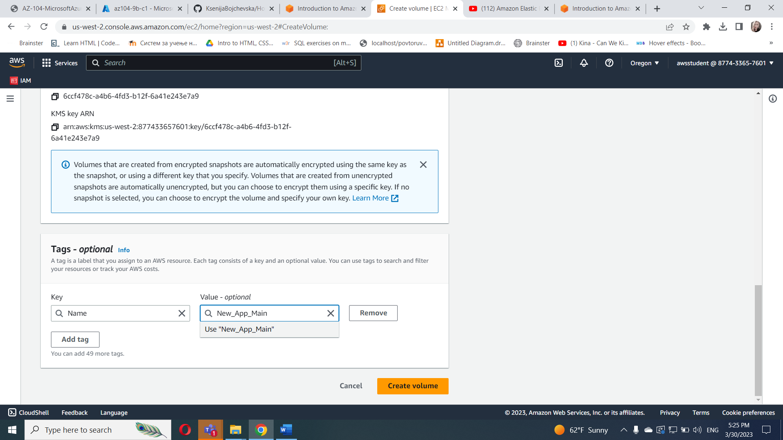

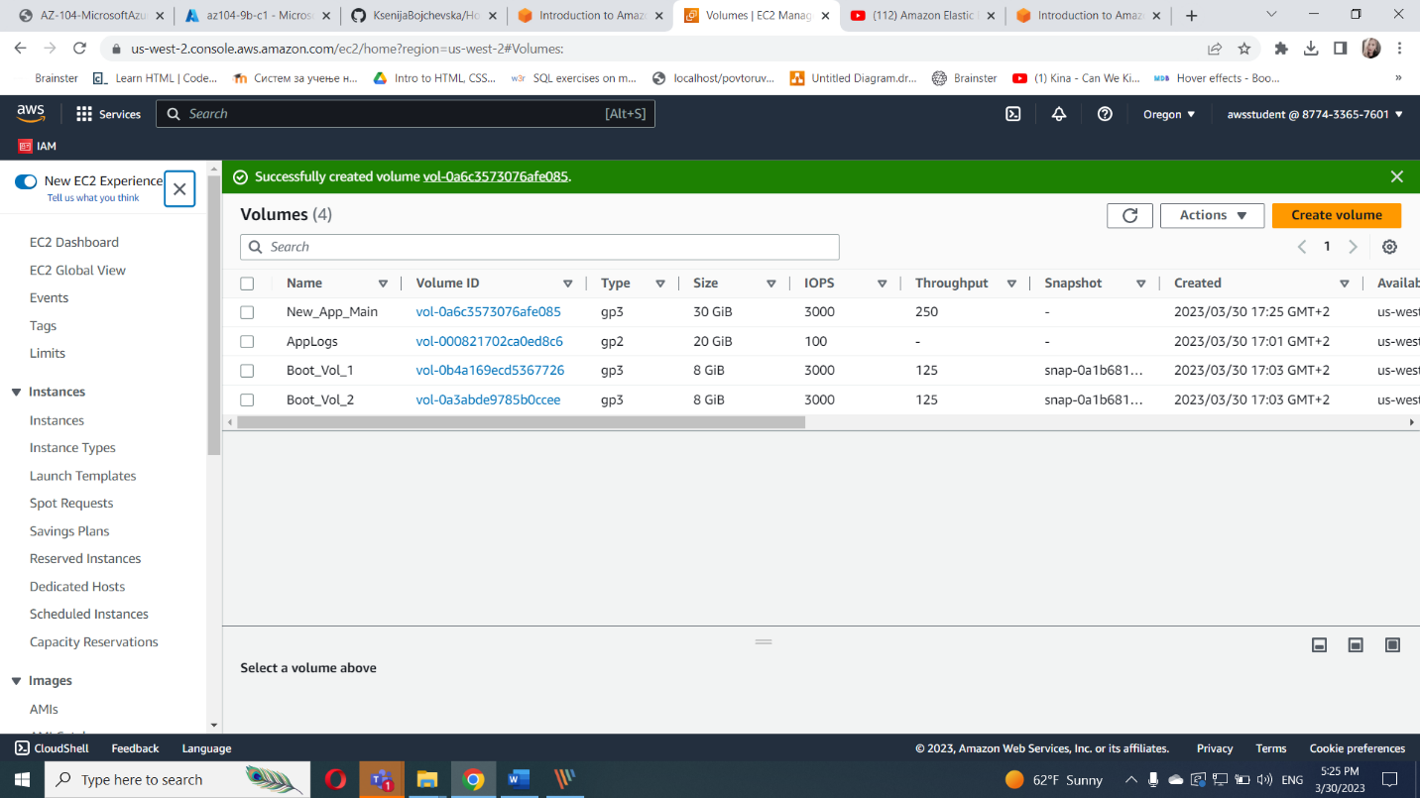

We can see that is available

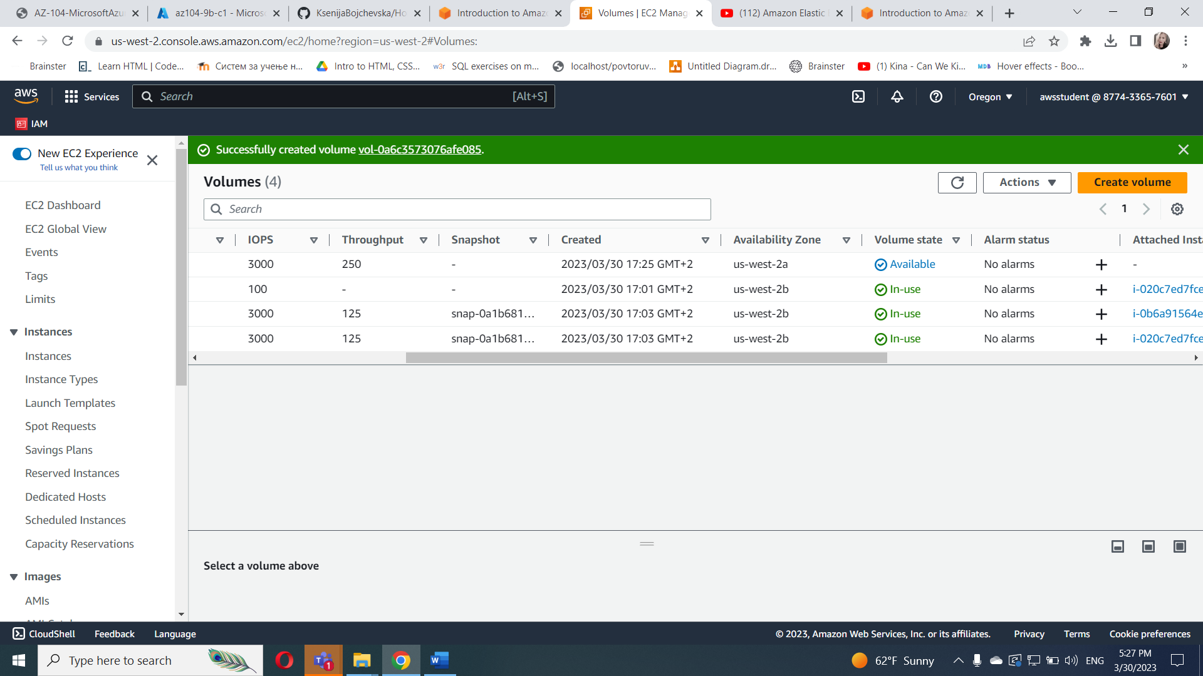

Task 1.3 Attach EBS volume to an EC2 instance

Select the created volume

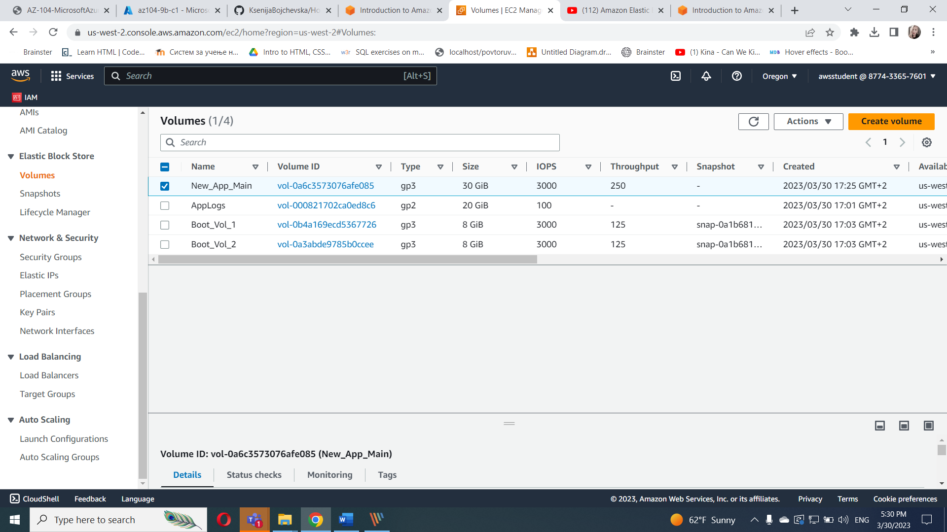

On the actions, click attach volume

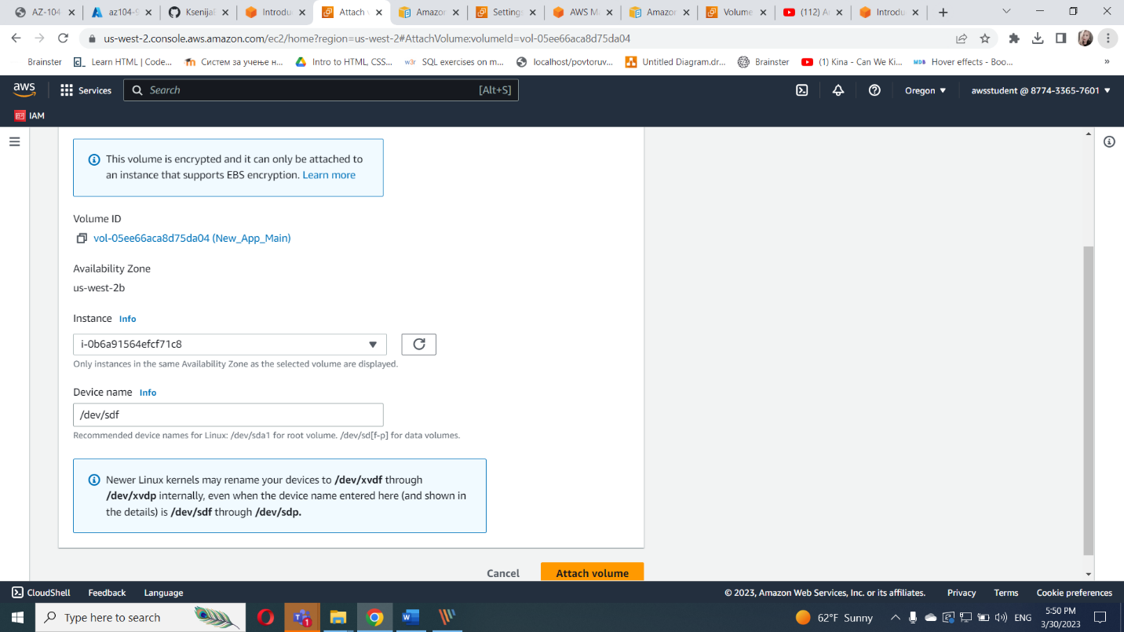

Now status is in-use

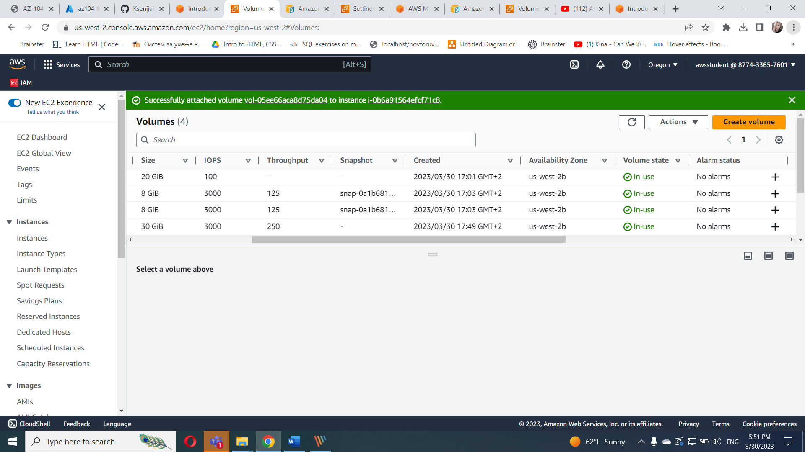

Go to instances form the created volume and click storage

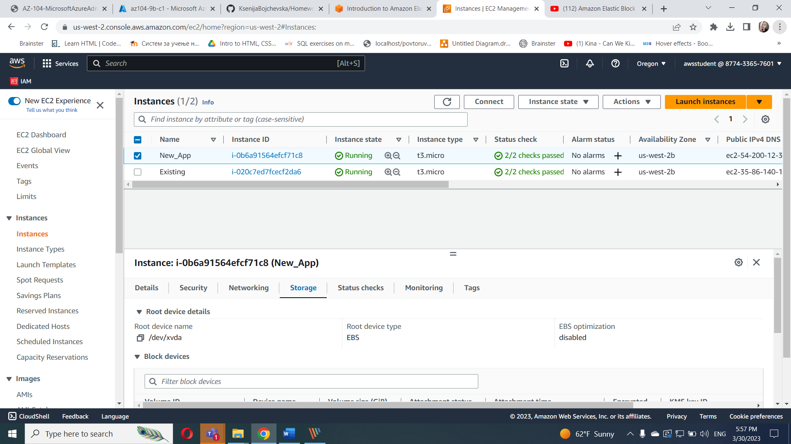

Go to block devices

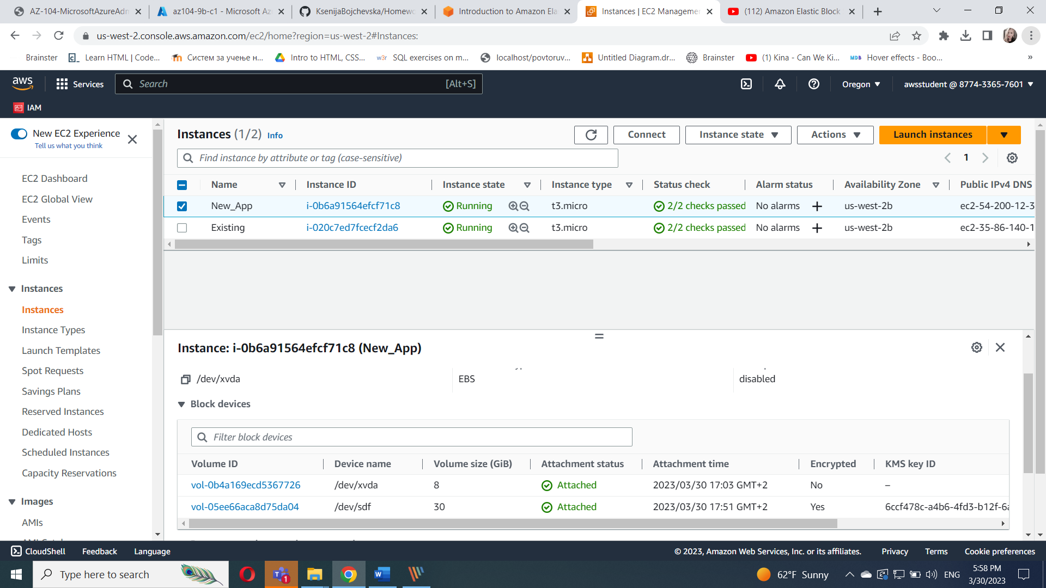

Task 2 : Create and configure a file system on an attached EBS volume

In the Instances , select New_App and Connect

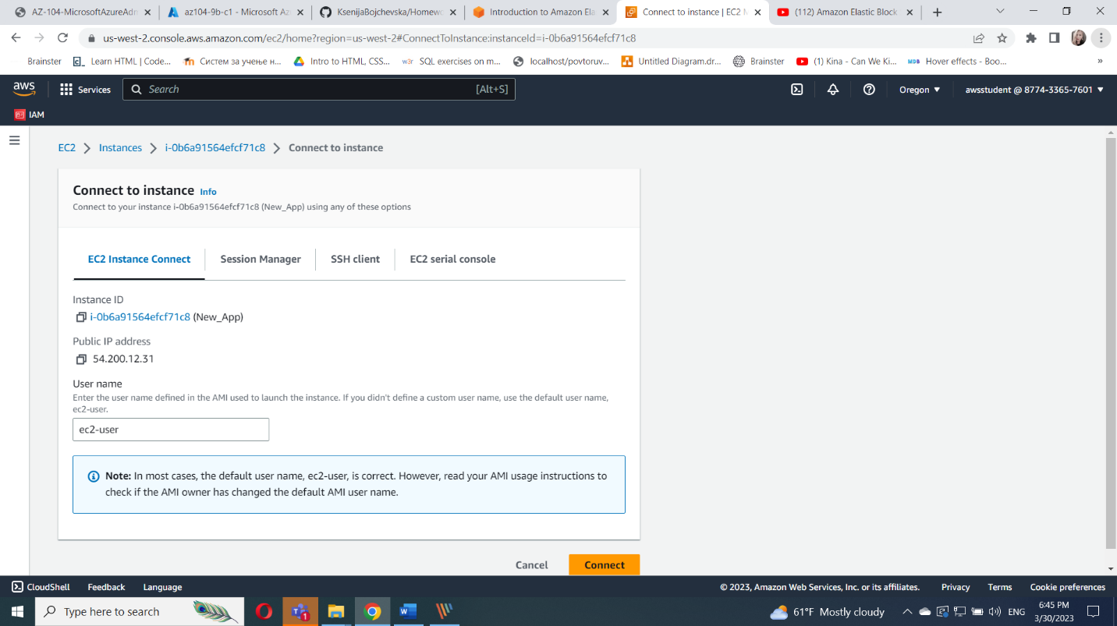

Run the command df -h

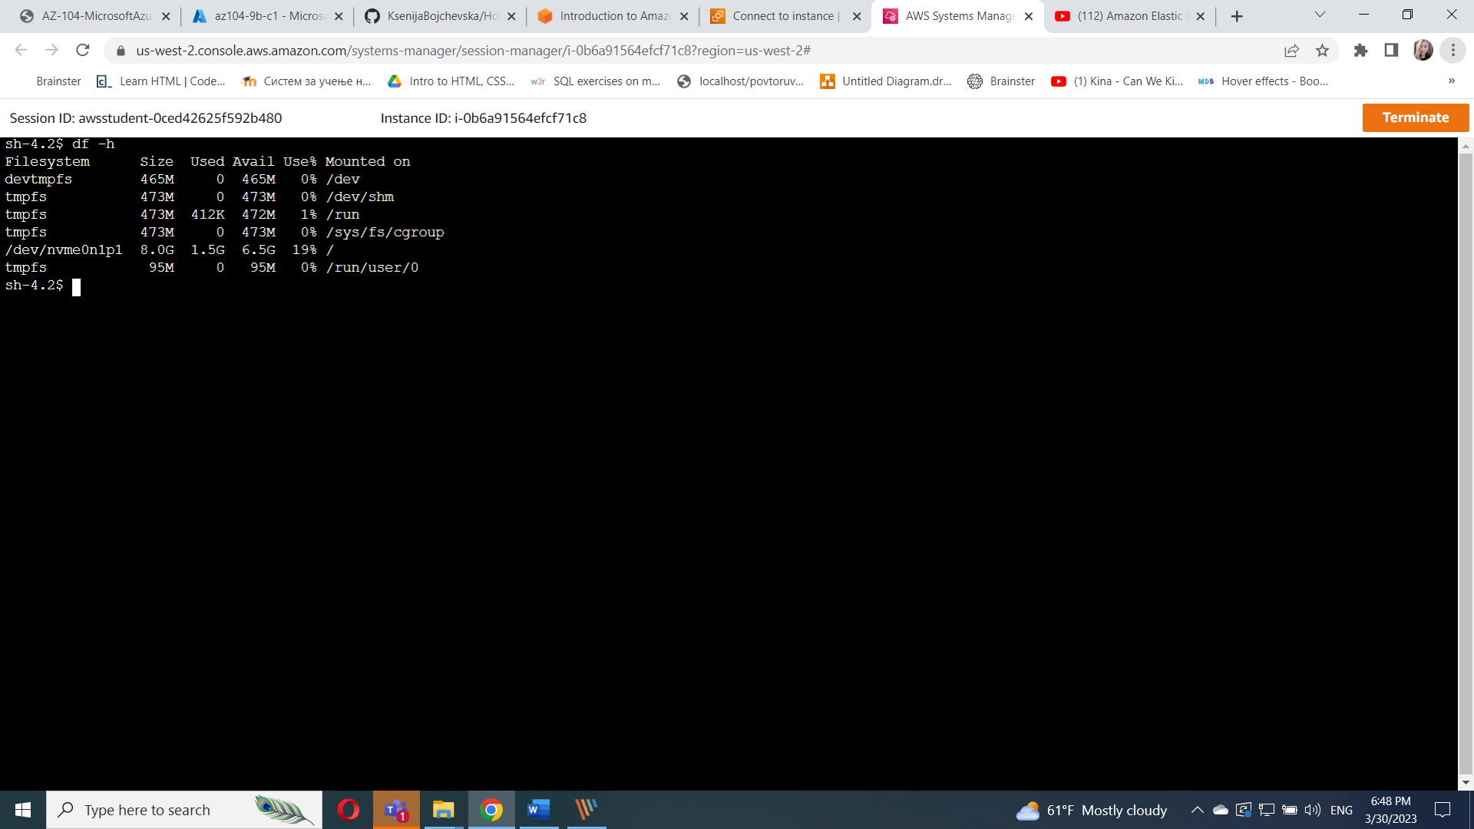

Run the command sudo mkfs -t ext3 /dev/sdf

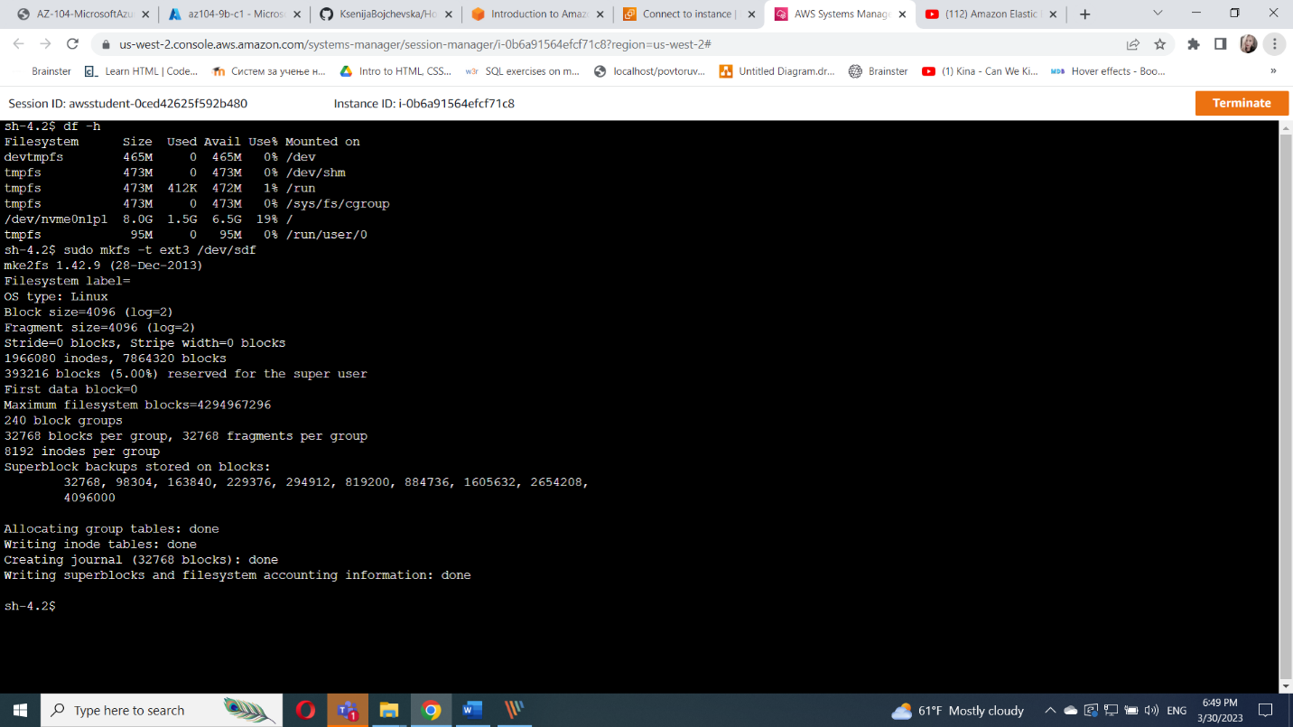

Run the command

sudo mkdir /mnt/data-store

sudo mount /dev/sdf /mnt/data-store

echo "/dev/sdf /mnt/data-store ext3 defaults,noatime 1 2" | sudo tee -a /etc/fstab

cat /etc/fstab

df -h

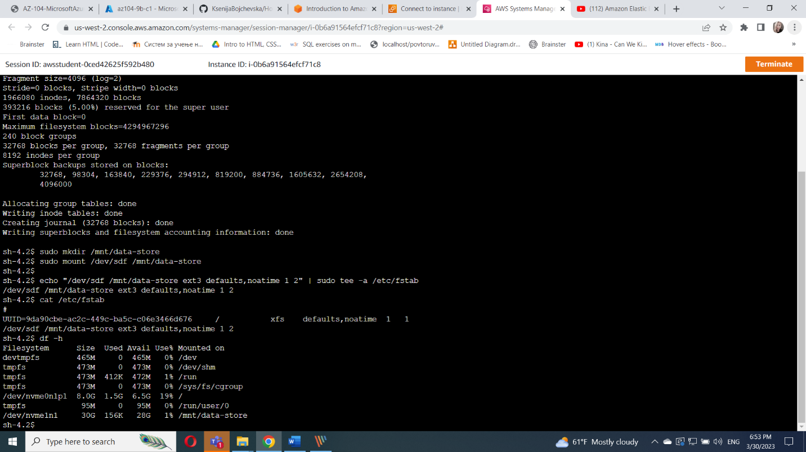

Run the commands

sudo sh -c "echo some text has been written > /mnt/data-store/file.txt"

cat /mnt/data-store/file.txt

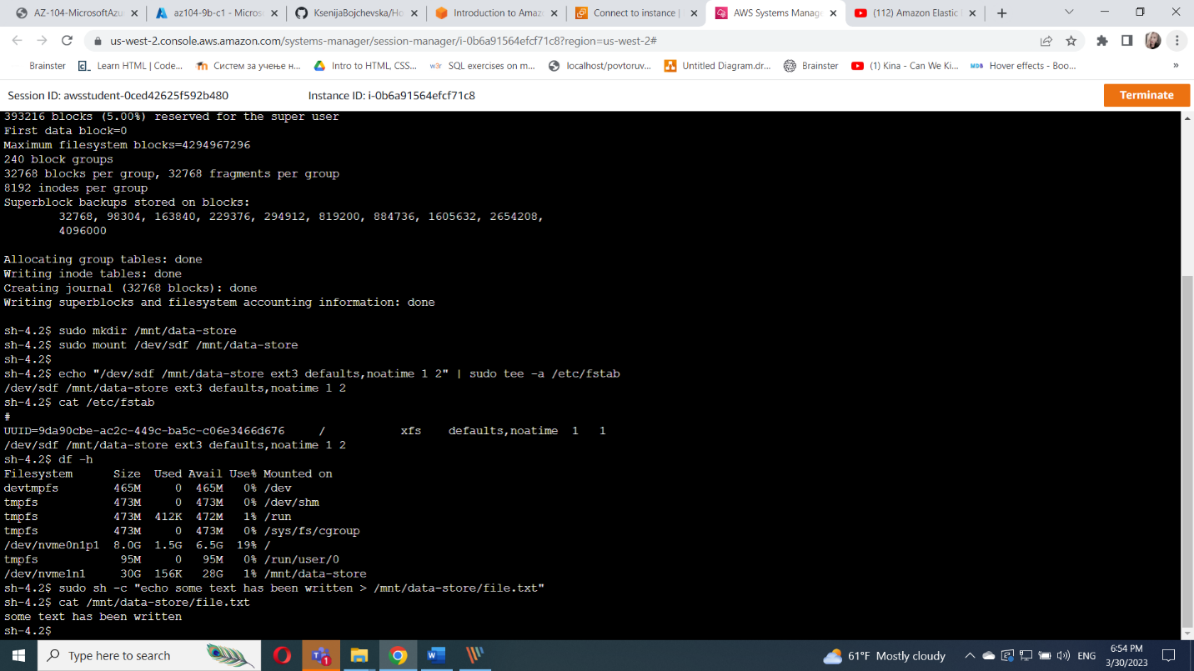

Task 3 : Modify the EBS volume size and expand the file system on the volume

3.1 Modify the size on existing EBS volume

On elastic block store go to volumes

Select the New_App_Main and click on actions and select Modify

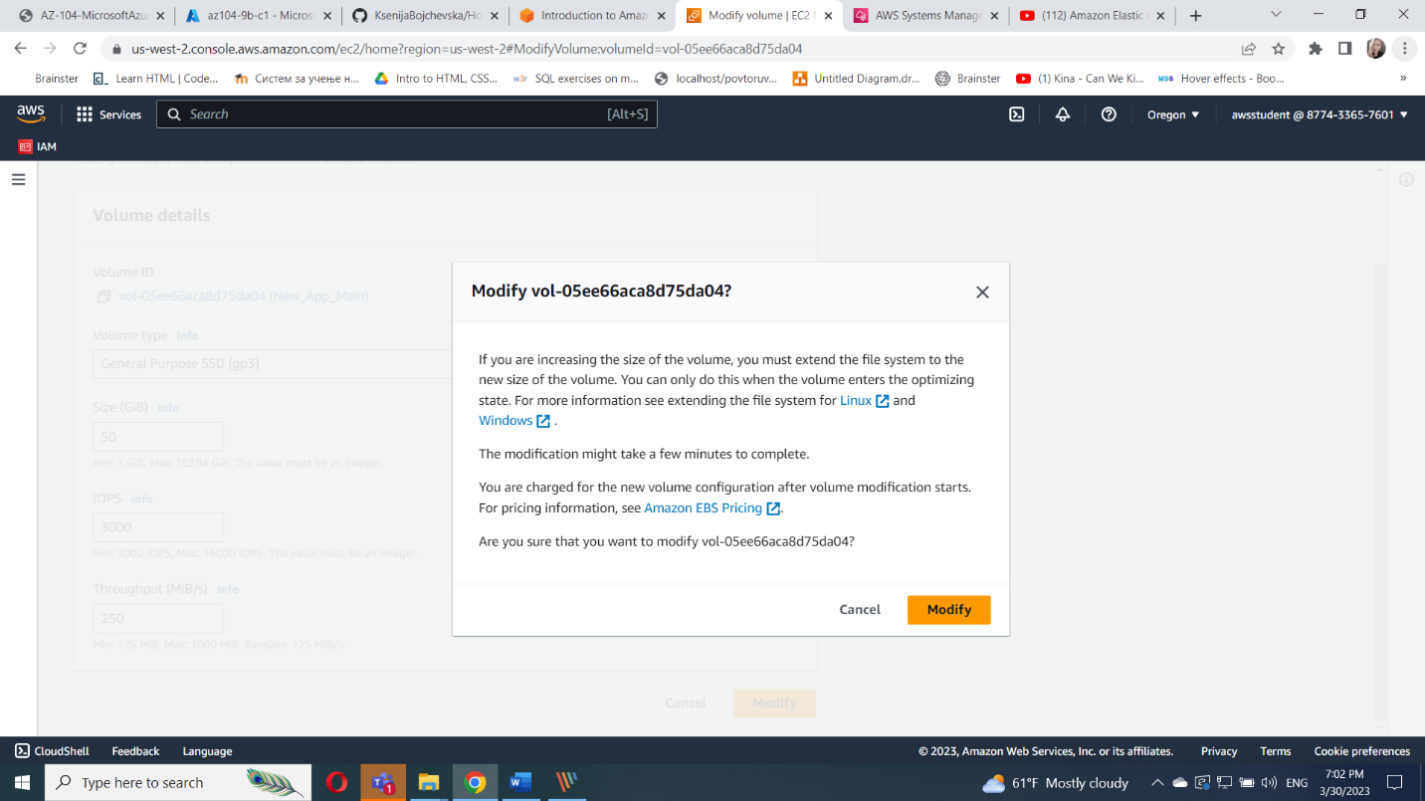

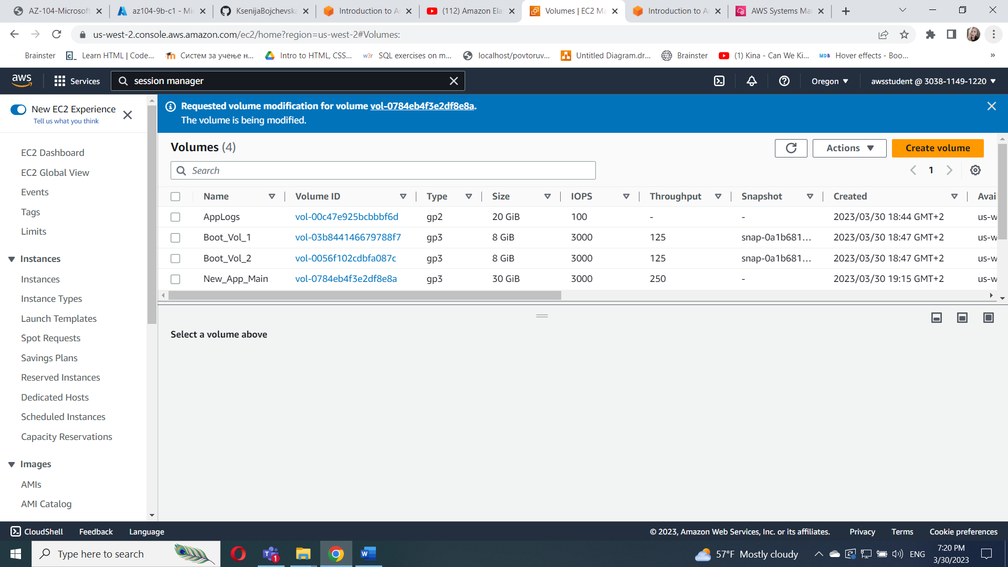

Task 3.2 : Expand the volume of your file system

Run the command lsblk

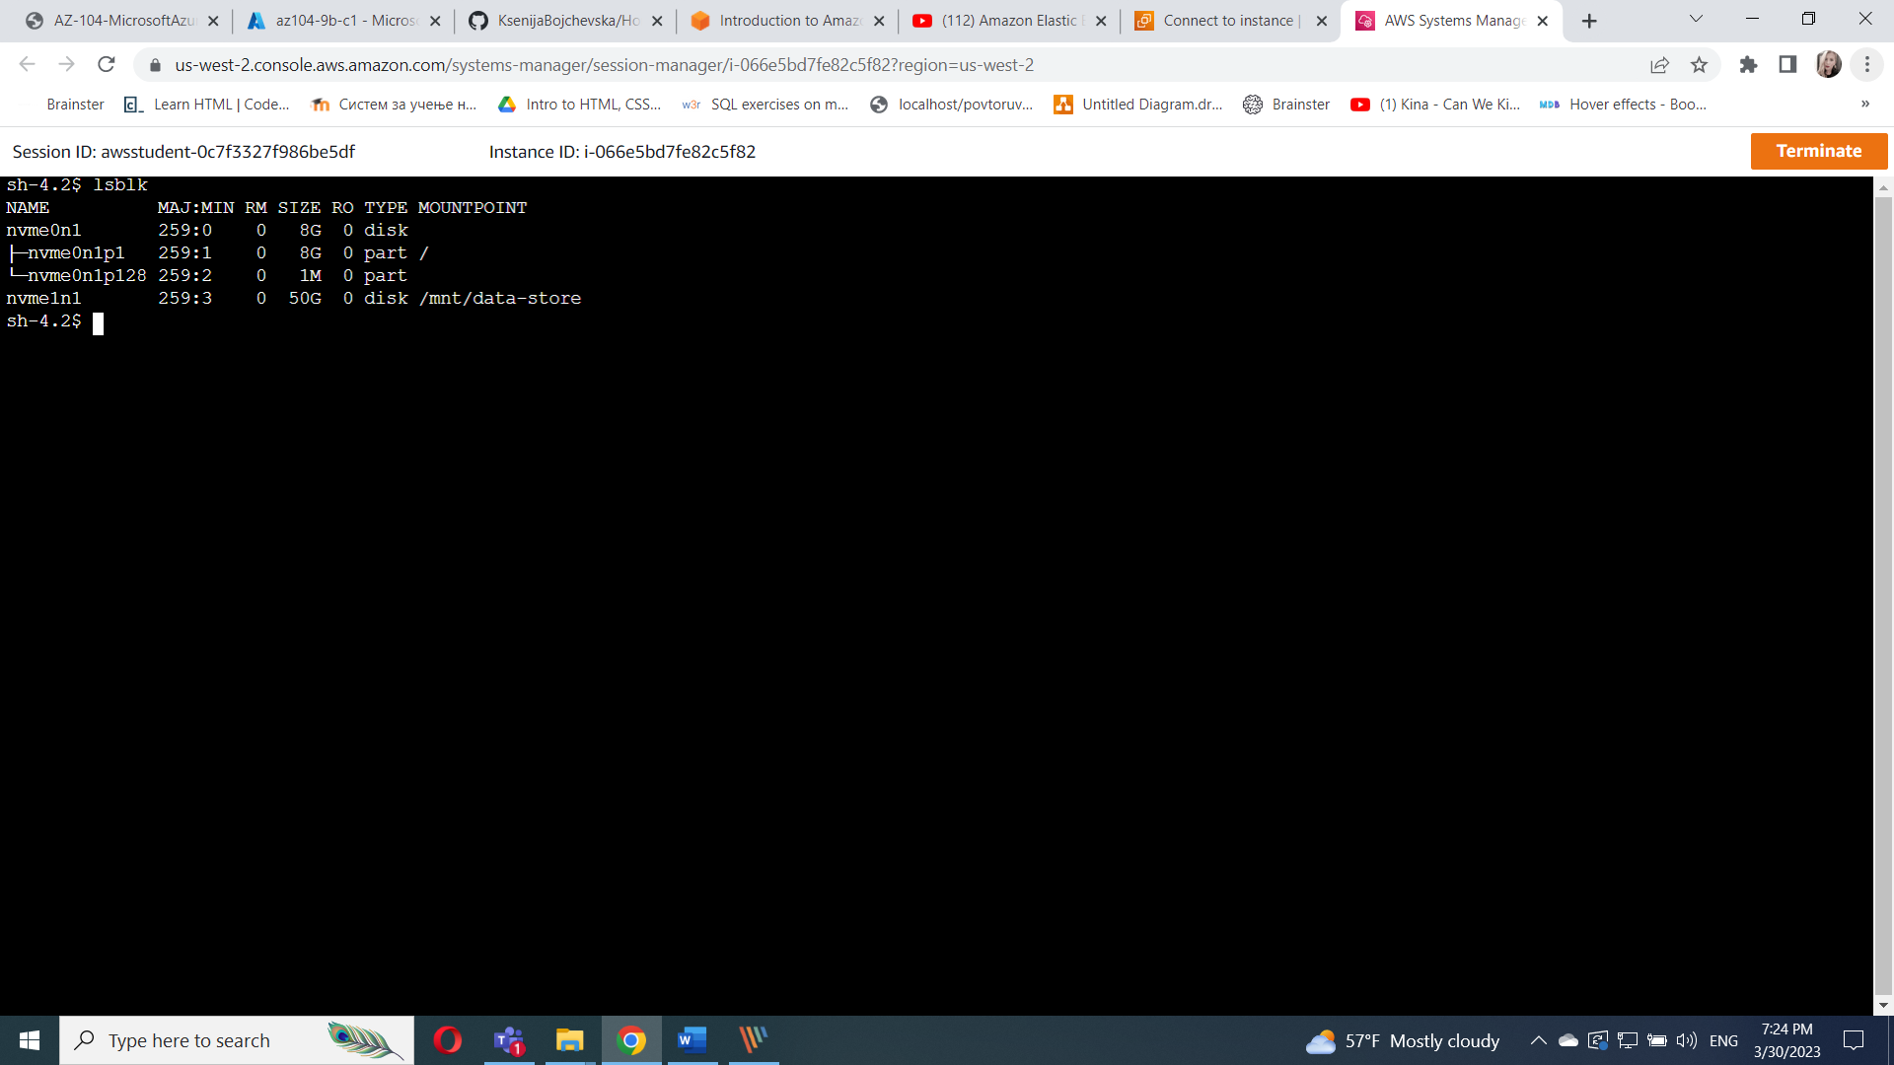

Run the command df -h

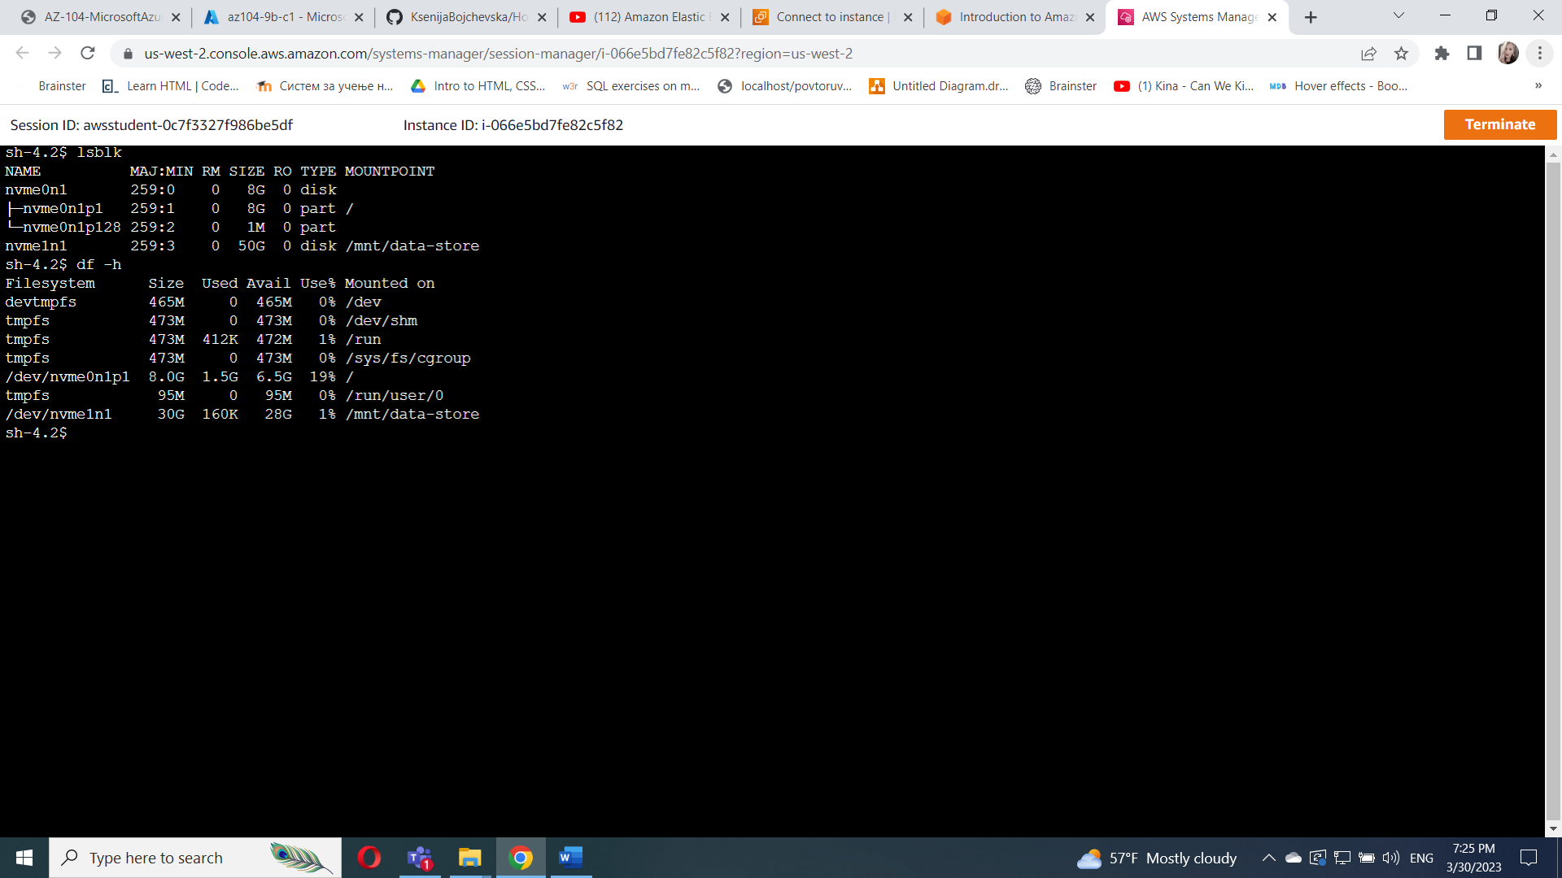

Run the command sudo resize2fs /dev/nvme1n1

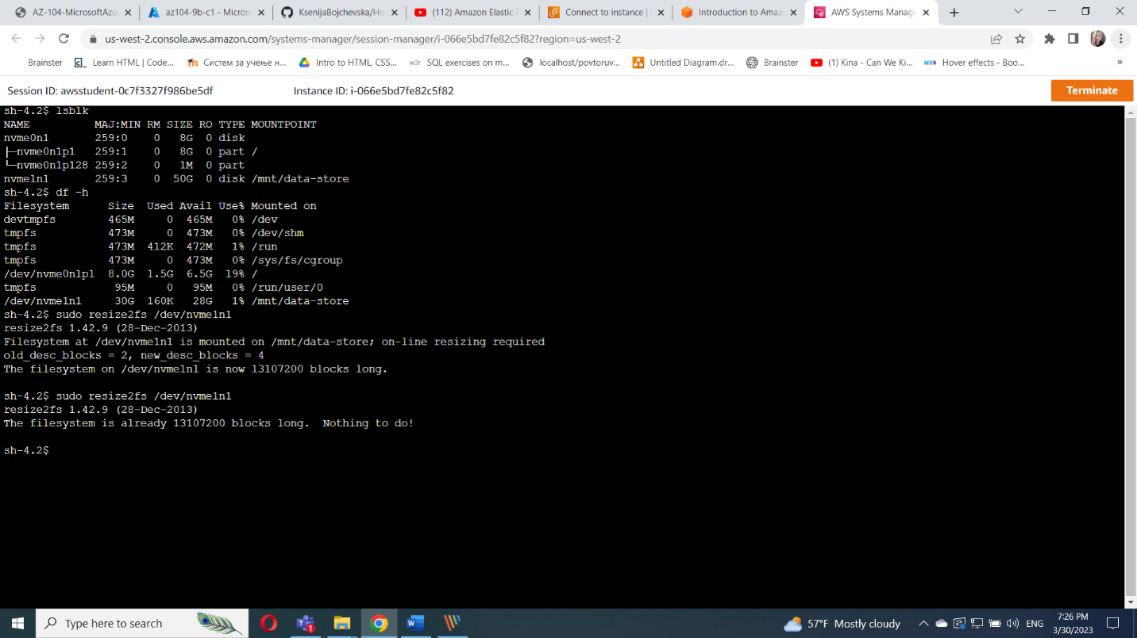

Run the command df -h

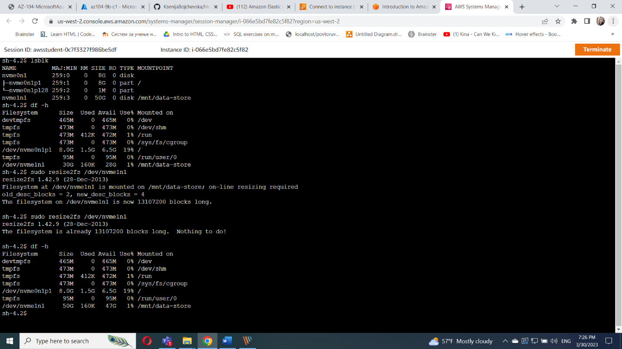

Task 4 : Modify the EBS volume type and provisioned performance for an existing app

Go elastic block store and click volumes

Choose AppLogs , choose actions and modify volume

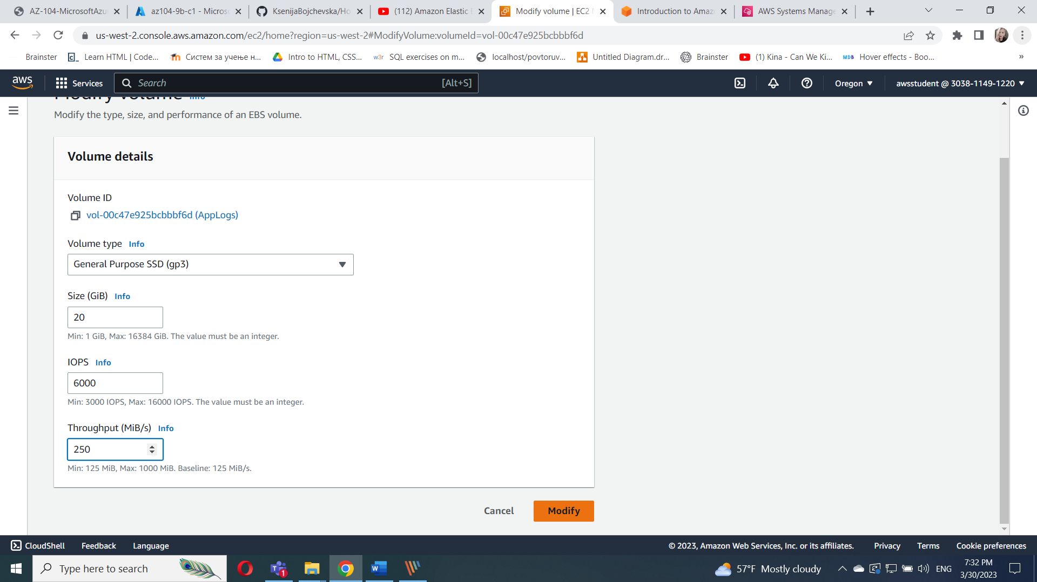

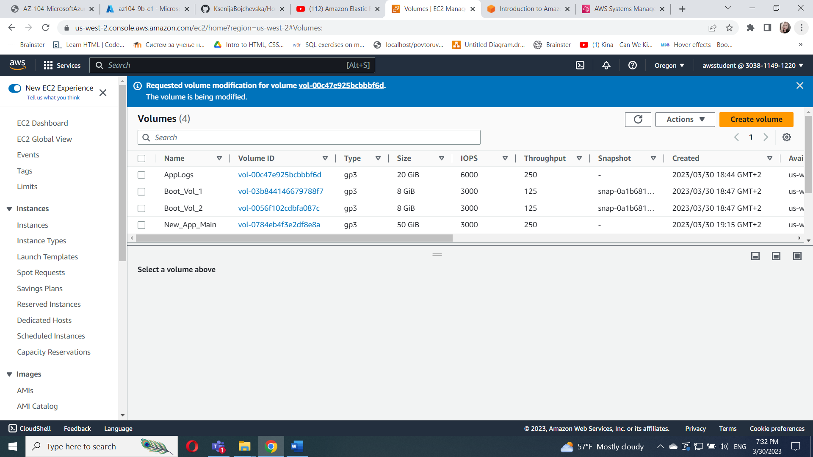

Task 5 : Configure a snapshot for an existing EBS volume

Go to volumes and click New_App_Main

On actions choose create Snapshot

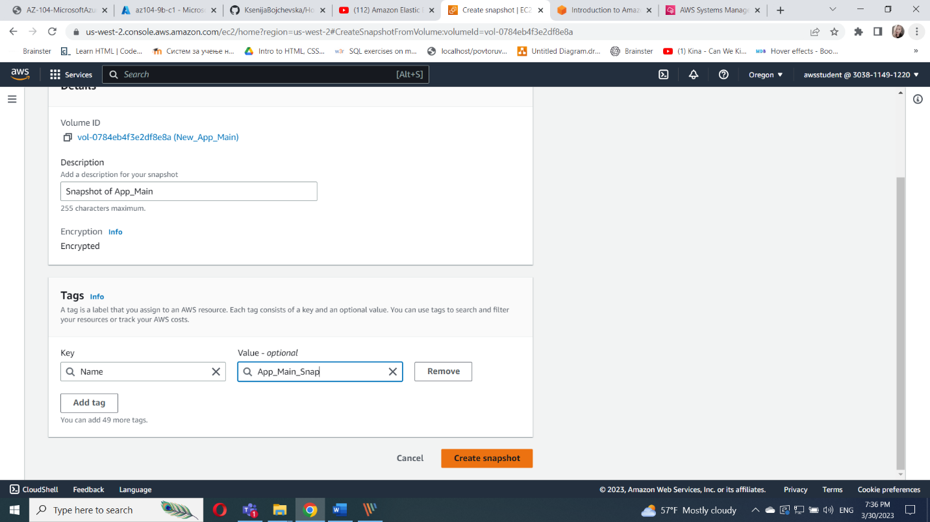

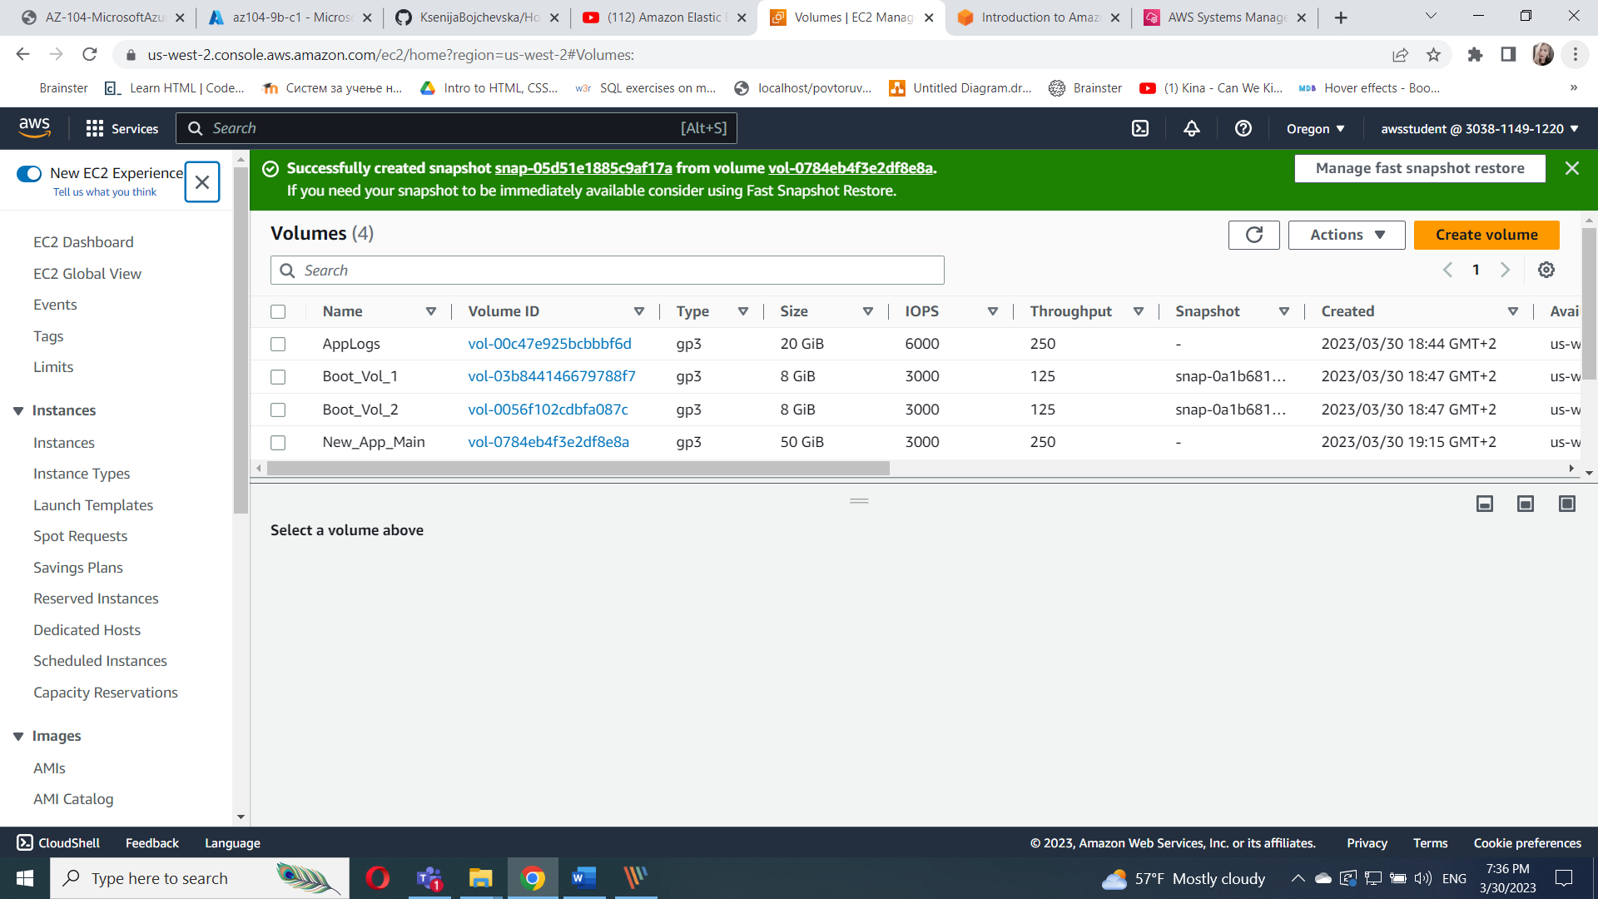

On elastic block store coose snapshots

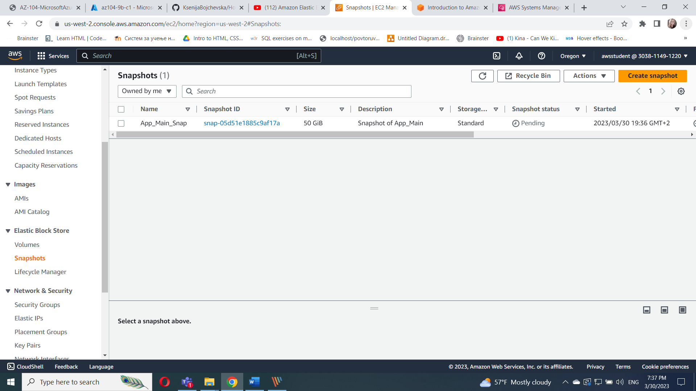

Task 6 : Restore an EBS volume from an existing snapshot

On elastic block store , click on snapshots and select App_Main_Snap

And in actions create volume

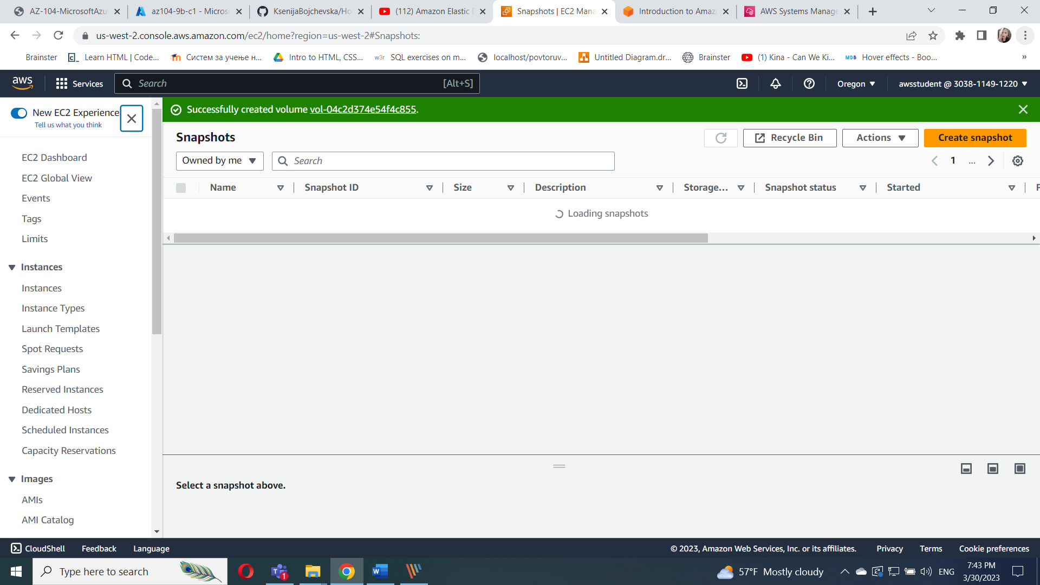

On elastic block store choose volumes and selected restored_App_Main

Choose actions and and attach volume

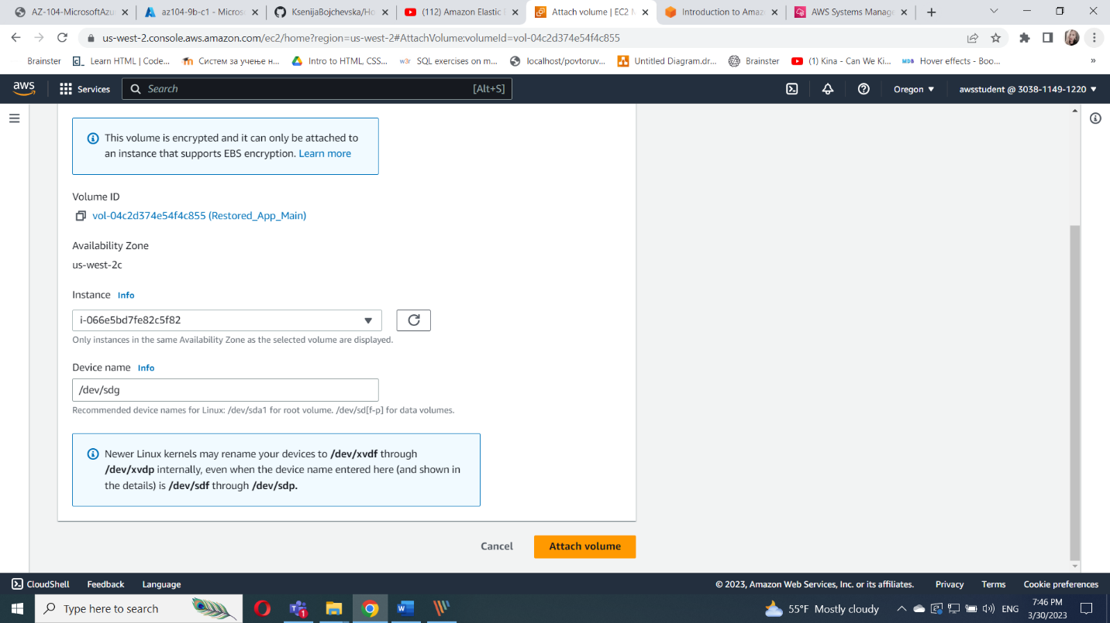

In terminal run the commands

sudo mkdir /mnt/data-store2

sudo mount /dev/sdg /mnt/data-store2

lsblk

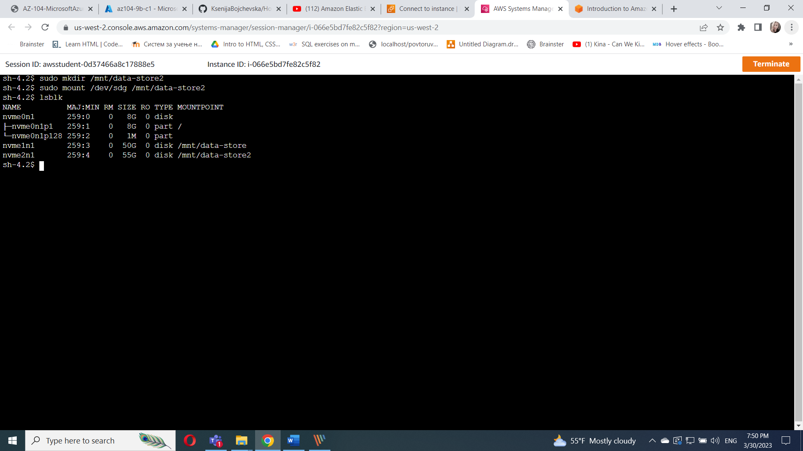

Run the command df -h

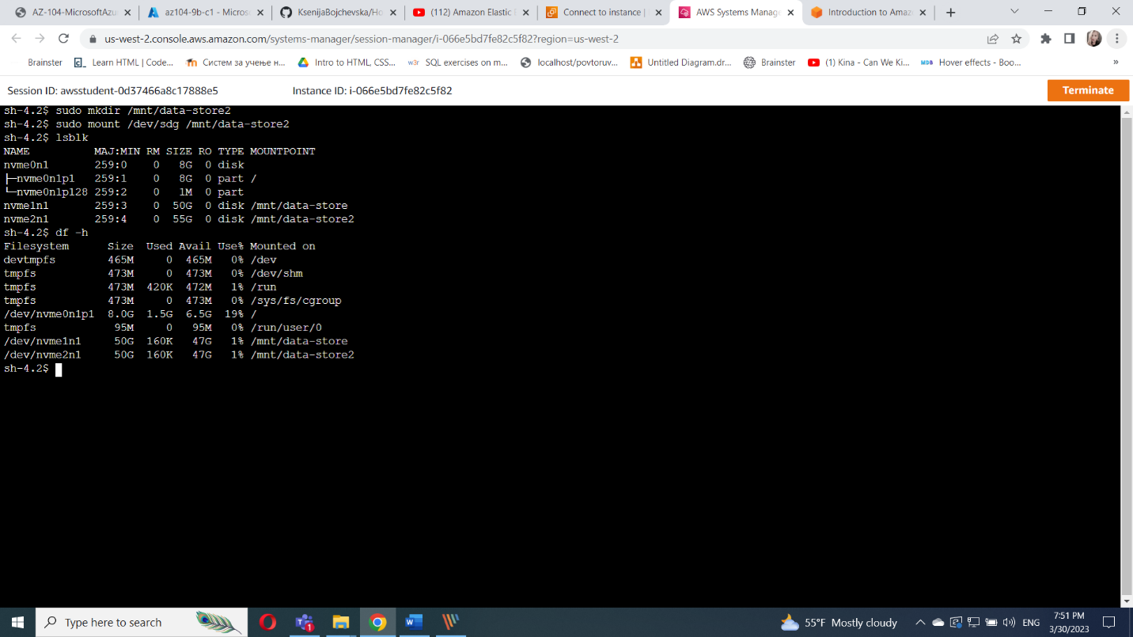

Run the command sudo resize2fs /dev/nvme2n1



Run the commands

df -h

ls /mnt/data-store2/

cat /mnt/data-store2/file.txt

